Index

Solution Overview 5

Integration Architecture 6

Key Definitions 6

Managed Package 6

Custom Objects 8

Page Layout 8

Workflow Rules 8

Building Blocks 9

Microsoft Dynamics Login 9

Create New Proposal 9

Proposal Layout 10

Proposal Identifiers 10

Configure Products 11

Generate Quote/Proposal 11

Present Quote/Proposal 12

Accept Quote/Proposal 13

Status and Status Category 13

To-Be Process Flows 14

Quote/Proposal Flow 14

Create a Project Quote/Proposal 15

Create a Customer Quote/Proposal 15

Configure Products 16

Review Pricing and Apply Discounts 17

Review and Finalize Shopping Cart 18

Generate and Present the Proposal 19

Negotiations and Proposal Revisions 19

Use Cases 20

Master Configuration 20

Use Case 1: Pricelist Creation: 20

Use Case 2: Product Catalog and Category Creation 20

Use Case 3: Product Creation (Standalone): 22

Use Case 4: Bundle Creation 23

Proposal Use cases 24

Use Case 1: Create a Project Quote 24

Use Case 2: Create a Customer Master Quote 26

Use Case 3: Calculate Distance and Populate PriceList 26

Calculate Distance and Populate PriceList 26

Use Case 4: Configure Products 27

Use Case 5: Review Pricing and Apply Discounts 29

Use Case 6: Review Pricing visually 32

Use Case 7: Review and finalize Shopping Cart 34

Use Case 8: Approvals Submission 34

Use Case 9: Approvals – Approve/Reject 36

Use Case 10: Generate and Present the Proposal 37

Use Case 11: Negotiations and Proposal Revisions 38

Use Case 12: Proposal Acceptance 39

Use Case 13: Search 39

References 40

Action Items 41

Open Items 41

Closed Items 41

# Solution Overview

This section provides an overview of the CPQ CPQ solution designed for Project. CPQ CPQ provides out of the box functionalities which are included as part of the standard solution.

The enterprise capability can manage different types of quote/proposal’s, processes and a large number of users. The package is modularized and allows for complete visibility and control of the entire quoting process. This includes phases like request, quote creation and document generation.

The below points were taken into consideration while putting the solution together. These considerations will assist the CPQ administrators to understand, manage and support the solution appropriately.

* Standard functionalities provided by Microsoft Dynamics and CPQ would be used to configure and complete the requirements listed in the Business Requirement document.
* Both CPQ and Project would be involved during the configuration. However, this document primarily focuses on the deliverables that have been outlined for CPQ.
* Please refer to the Business Requirements in Jira.

Below diagram provides an Architecture overview of the solution

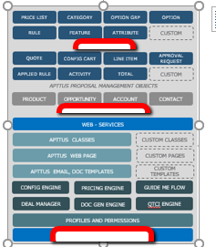

# Integration Architecture

The below diagram depicts the To-Be integration architecture that is deployed to support the overall project.

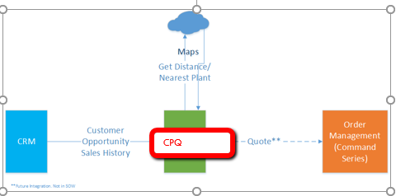

At a high level, this is the process flow for the project:

* Master data like the Catalogue hierarchy, Product and Pricing need to be first setup in the system. These dictates what the user can see and quote and configure via the catalogue. This master data setup can be done manually for small implementations and should be automated for larger implementations and data sets.
* Once a quote is created, a document can be generated.
* Once the quote is accepted, an Order can be created along with Assets(Not used in Project solution). This information can then be sent to the traditional Order Management and Provisioning systems and the responses from those systems can be written back into CPQ. This outbound integration can be implemented via Microsoft Dynamics.com outbound integration or via a pull mechanism from an external system using Microsoft Dynamics.com API’s. This integration is not in scope of this project.

# Key Definitions

## Managed Package

Managed packages are typically used by Microsoft Dynamics.com partners like CPQ to distribute and sell applications to customers. These packages must be created from a Developer Edition organization. Using the AppExchange and the License Management Application (LMA), developers can sell and manage user-based licenses to the app. Managed packages are also fully upgradeable. To ensure seamless upgrades, certain destructive changes, like removing objects or fields, cannot be performed.

Managed packages also offer the following benefits:

* Intellectual property protection for Apex
* Built-in versioning support for API accessible components
* The ability to branch and patch a previous version
* The ability to seamlessly push patch updates to subscribers
* Unique naming of all components to ensure conflict-free installs

The following definitions illustrate these concepts:

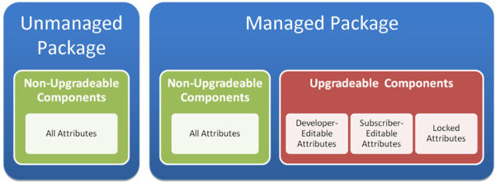

## Custom Objects

Custom objects are custom database tables that allow you to store information unique to your organization. For example, your organization may want to create a custom object called Quotes to store data for your company’s sales quotes. After you define a custom object, you can:

* Create custom fields.
* Associate the custom object with other records and display the custom object data in custom related lists.
* Track tasks and events for custom object records
* Build page layouts
* Customize the search results and the custom object fields that display in them
* Create a custom tab for the custom object
* Create reports and dashboards to analyze custom object data
* Share your custom objects, custom tabs, custom apps, and any other related components with other Microsoft Dynamics users on Force.com AppExchange.
* Import custom object records

Key Custom Objects used in this solution are Scatterplot Data, last Transaction data and Top Selling Product

## Page Layout

Page layouts control the layout and organization of buttons, fields, Visual force, custom links, and related lists. They also help determine which fields are visible, read only, and required. Page layouts can include certain Visual force pages that are rendered within a field section when the page displays. You can control the size of the Visual force pages, and determine whether or not a label and scroll bars display.

## Workflow Rules

Workflow automates the following types of actions based on your organization's processes:

1. Tasks - Assign a new task to a user, role, or record owner.
2. Email Alerts - Send an email to one or more recipients you specify.
3. Field Updates - Update the value of a field on a record.
4. Outbound Messages - Send a secure, configurable API message (in XML format) to a designated listener.

Each workflow rule consists of:

* Criteria that cause the workflow rule to run.
* Immediate actions that execute when a record matches the criteria.
* Time-dependent actions that queue when a record matches the criteria, and execute according to time triggers.

# Building Blocks

The following topics have been included in this document so that it provides a basic understanding of the various functionalities that would be available as part of the solution.

## Microsoft Dynamics Login

To create a Quote using CPQ Proposal Management, a user needs to have access to Microsoft Dynamics with adequate security permissions.

## Create New Proposal

The user who creates the record is identified by the field *‘Created By’* and the owner of the record is identified using the field *‘Owner’.* New Proposal can be initiated from the Proposals tab.

The respective *‘Record type’* which signifies the Agreement request or type must be selected.

## Proposal Layout

This represents the page layout for the Quote/Proposal object. Based on the user’s profile, layouts will be designed to display fields to the end user. Fields will be grouped in sections based on orientation provided by Microsoft Dynamics.

## Proposal Identifiers

*‘Proposal Id’* is populated by the system based on a pre-defined format. It is recommended to have minimal fields on the page which the user should enter. Price List will be derived based on the Account/Opportunity fields. As an example, below, the Expected Start Date and End Date are available for the user to enter if required.

## Configure Products

After the Proposal is created and a price list specified, the user can then click on ‘Configure Products’ to go to the Catalog to select and add the required products to the shopping cart.



In the Catalog, you can click on the required Category of products and drill down further to select the desired product. You can also search for the product by name.

Once you find the product, you can add a product to the shopping Cart or click on ‘Configure’ if it’s a Bundle.

When all the desired products are added to the shopping Cart, the users can ‘Finalize’ the Cart or click on ‘Submit for Approval’ if there are approvals required.

|  |  |  |
| --- | --- | --- |
| **Sample Catalog UI** | **Add Products or Configure** | **Finalize or Submit for Approval** |
|  |  |  |

## Generate Quote/Proposal

The user will have the ability to generate the document using a pre-defined template. The standard functionalities needed for previewing and generating documents are provided using the buttons available in the *‘Actions’* section.

On clicking *‘Generate’* a wizard is launched which allows the user to select the desired template and generate the document in formats such as doc, pdf or rtf. The generated document can include a watermark *‘Draft’*.

## Present Quote/Proposal

After the quote is generated, the generated document preview is generated. This quote is then ready to be presented to the customer using the Email button.

Clicking on the Email button takes you to the next screen where you can enter the Recepient email, and Subject and send to the recipient. “Mark as presented” check box ensures that the Quote/Proposal status is changed to “Presented”

## Accept Quote/Proposal

The final phase of the Quote lifecycle is about executing the Proposal. Within the CPQ managed package, the term is known as *activation*. The system will provide the user the *‘Activate’* button available within the *‘Actions’* section for activating the Quote/Proposal manually.



## Status and Status Category

The Status Category and Status fields indicate where the Quote/Proposal is in the workflow. It also determines which action buttons are available. The Status Category and Status fields are automatically changed based on Action Buttons.

# To-Be Process Flows

The following diagrams represent the detail business processes for Project. Steps in these diagrams represent the to-be process details.

## Quote/Proposal Flow

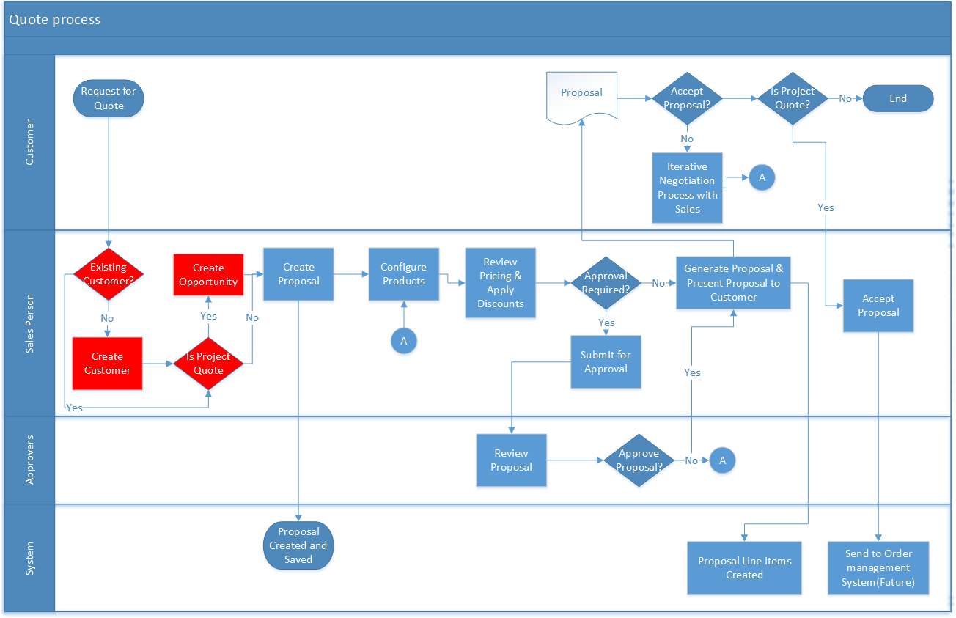

## Create a Project Quote/Proposal

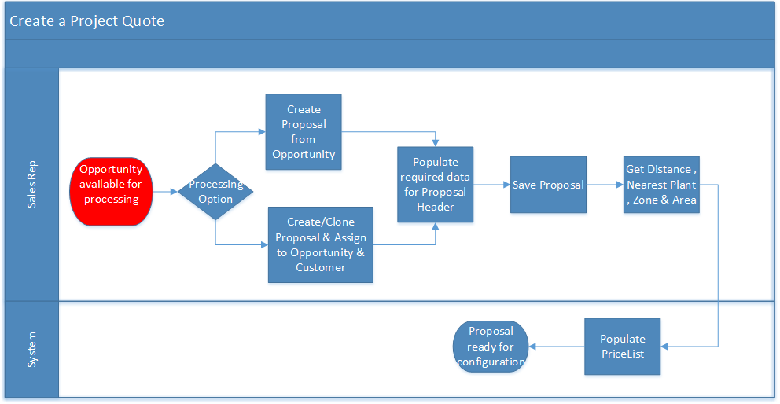

## Create a Customer Quote/Proposal

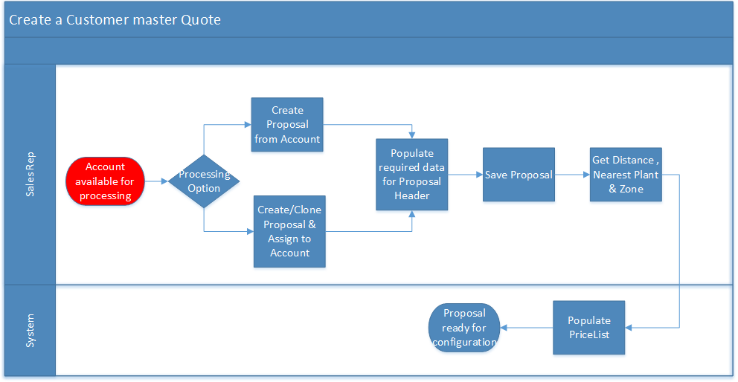

## Configure Products

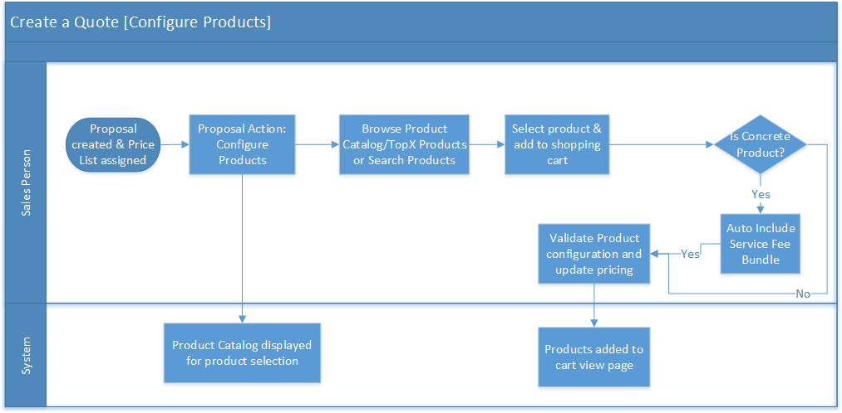

## Review Pricing and Apply Discounts

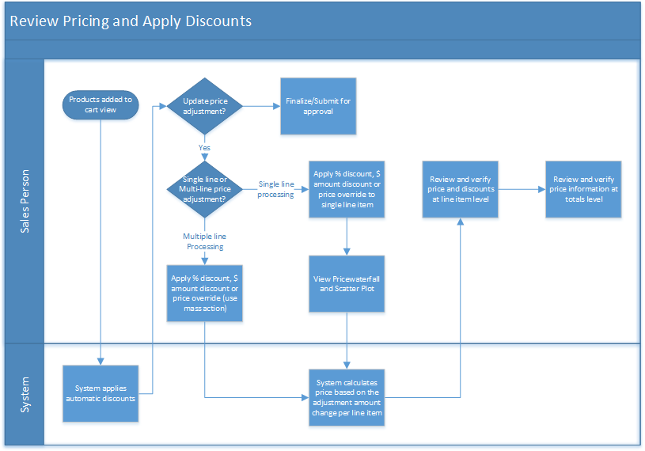

## Review and Finalize Shopping Cart

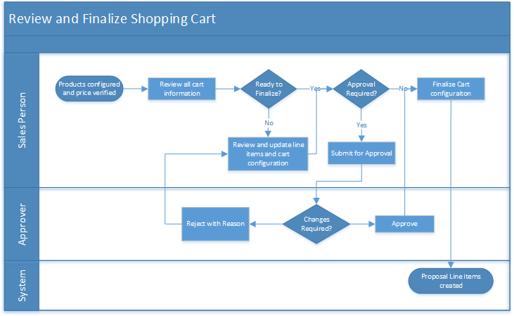

## Generate and Present the Proposal

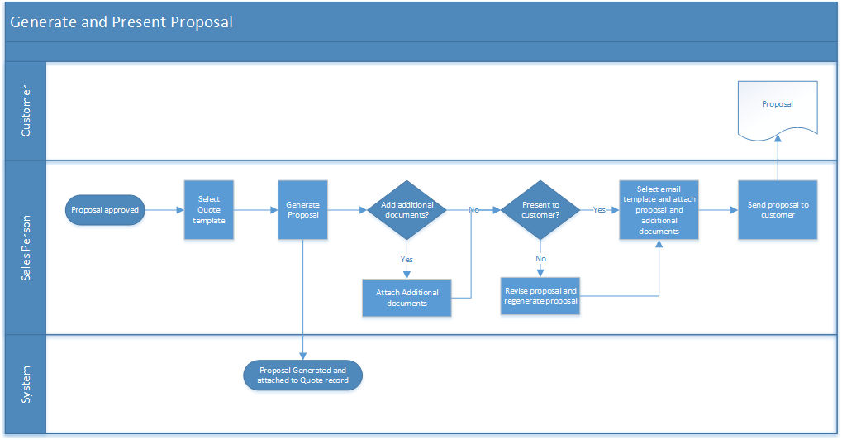

## Negotiations and Proposal Revisions

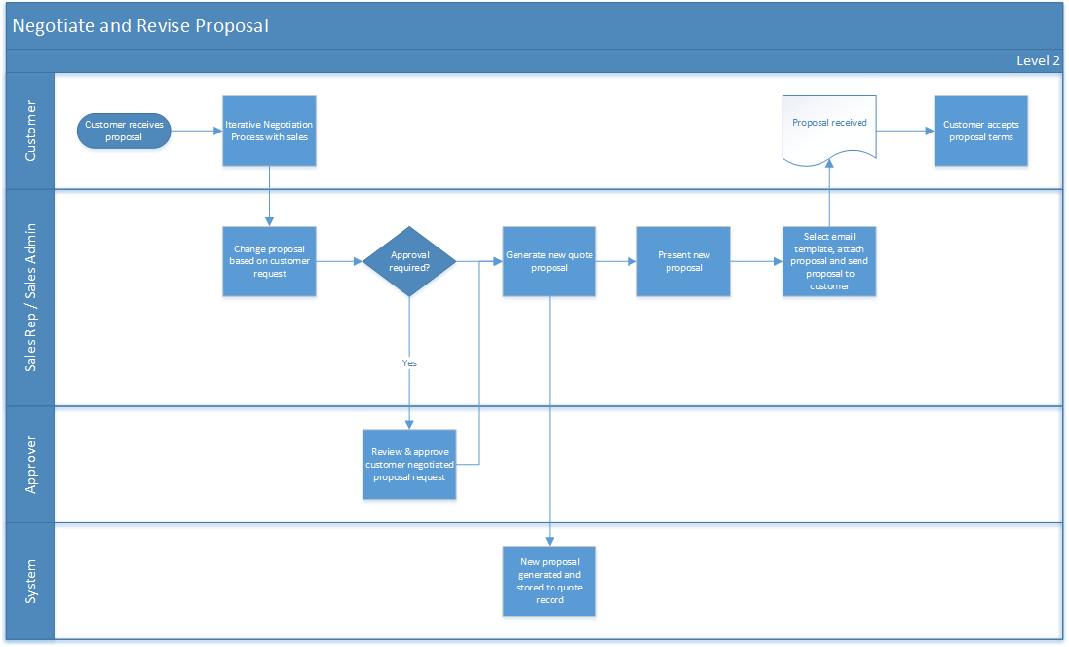

# Use Cases

## Master Configuration

### Use Case 1: Pricelist Creation:

|  |  |
| --- | --- |
| **Actors** | Sales Admin |
| **Description** | Sales Admin sets up the Pricelist in system |
| **Pre-conditions** | 1. User Successfully logs in to the Microsoft Dynamics |
| **Steps** | 1. User logs in to Microsoft Dynamics. 2. User clicks on “Price Lists” tab and clicks on ‘New’ 3. User provides the Price List name, Description, Currency and other important details and clicks on Save. |
| **Post-Conditions** | 1. Price List gets created. |
| **Assumptions** | 1. User has required permissions. |
| **Solution Approach** | OOB Price List Creation. (US127)  Below Custom fields to be Created on Price List   * + 1. Area- Picklist. Mandatory. (Values: Vic Metro(Default)) |

### Use Case 2: Product Catalog and Category Creation

|  |  |
| --- | --- |
| **Actors** | Sales Admin |
| **Description** | Sales Admin Product Catalog and Product Categories in system |
| **Pre-conditions** | 1. User Successfully logs in to the Microsoft Dynamics 2. Price List has been created 3. Products and Price List Items have been created |
| **Steps** | 1. User logs in to Microsoft Dynamics. 2. User clicks on “Categories” tab and clicks on ‘New’ 3. User provides the Category Name, Type and Active Flag and clicks on ‘Save’ 4. After creating the Category, User Creates Hierarchy of Products by clicking on ‘Hierarchy Manager’ on the Category. 5. User clicks on ‘Add Sub Category’ and adds branches to the Main Category. 6. On the Sub Category, User Searches for a Products and clicks on ‘Associate’ and then ‘Save. 7. To Add the Catalogue to the Price List, User clicks on ‘CPQ console’ tab. 8. User Clicks on ‘Manage Price Lists’, Selects the Price List and clicks on ‘New Price List Category’ 9. In the ‘Hierarchy’ look up fields, User searches for the Category he created and clicks on ‘Save’ 10. Run the Category Maintenance batch update. |
| **Post-Conditions** | 1. Main Category gets created 2. Branches to the Main Category is created 3. Categories attached to Price List |
| **Assumptions** | 1. User has required permissions. 2. User has Product hierarchy information |
| **Solution Approach** | CPQ provides CPQ console to manage categories. Within CPQ Console:   * Manage Category Hierarchy and use hierarchy manager to manage hierarchies (add, change, move, remove and reorder hierarchies)   The below diagram represents the Category hierarchy structure defined for the implementation.  Refer the Tab “Step 3 Setup Categories” of the “CPQ - Product Workbook”. For the Link to the workbook, go to the references section of this document.  While creating the categories/sub-categories through Hierarchy Manager, Select the checkbox ‘Default Search Category’ for the category that shall be selected by default on the Catalog page for Product Search.  Select the checkbox ‘Expanded by Default’ for the category that shall be opened/expanded by default on the Catalog page  In the ‘Config Settings’ tab, set ‘Hide Single Top Category’ to TRUE in case the topmost category in the category hierarchy is not to be displayed in the catalog. |

### Use Case 3: Product Creation (Standalone):

|  |  |
| --- | --- |
| **Actors** | Sales Admin |
| **Description** | Sales Admin sets up the Standalone Products in system |
| **Pre-conditions** | 1. User Successfully logs in to the Microsoft Dynamics 2. Price List has been created |
| **Steps** | 1. User logs in to Microsoft Dynamics. 2. User clicks on “Products” tab and clicks on ‘New’ 3. User provides the Product name, Configuration Type, Product Code and other important details and clicks on Save. 4. On the Product, User clicks on ‘New Price List Item’ in the related lists 5. User enters Price List, Charge Type, List Price, Effective date, Expiration Date, Price Type, Frequency, Price Method and other important details and clicks on Save. 6. On the Price List Item, User Enters the ‘Charge Type Criteria’ and clicks ‘Ok’. (US127) |
| **Post-Conditions** | 1. Product gets created with Price List Item. |
| **Assumptions** | 1. User has required permissions. 2. User has Pricing details and attributes details to be assigned to Products. |
| **Solution Approach** | Below fields should be added to the product object and the Product Page   1. MPA : Number Field, Not Mandatory (This represents the wetness of concrete) 2. Non-Discountable : Picklist, Values-True, False, Mandatory (This specifies if the product is non-descountable)   Below values should be added to the UoM picklist  m3  unit  minute  hour  load  cylinder  test  set  bag  CPQ product also provides CPQ Console to manage Product modelling. Using the CPQ console:   * New Products can be added through ‘Add Products’ * Existing Products can be maintained through ‘Manage Products’   For setting up products, refer the Tab “Step 2 Setup Products” of the “CPQ - Product Workbook” located at <https://www.dropbox.com/s/mpg5z54u6tz8nny/CPQ%20-%20Product%20Workbook.xls?dl=0>  For setting up Price List Items, refer the Tab “Step 3 Setup Base Prices” of the “CPQ - Pricing Workbook”. For the Link to the workbook, go to the references section of this document. |

### Use Case 4: Bundle Creation

|  |  |
| --- | --- |
| **Actors** | Sales Admin |
| **Description** | Sales Admin created Bundles in the System |
| **Pre-conditions** | 1. User Successfully logs in to the Microsoft Dynamics 2. Price List has been created |
| **Steps** | 1. User logs in to Microsoft Dynamics. 2. User clicks on “Products” tab and clicks on ‘New’ 3. To create a Bundle Product, User provides the Product name, Configuration Type as ‘Bundle’, ‘Has options’ as yes, ‘Must Configure’ as yes and other important details and clicks on Save. 4. User Creates Hierarchy of Bundles by clicking on ‘Hierarchy Manager’ on the Category. 5. On the Sub Category, User Searches for a Products and clicks on ‘Associate’ and then ‘Save. 6. Run the Category Maintenance Job 7. To Create ‘Option Groups’, User clicks on ‘CPQ Console’ tab and clicks on ‘Add Categories’ 8. User provides the Category Name and Type as ‘Option Group’ 9. On the Category Detail Page, User clicks on ‘Hierarchy Manager’. 10. User Searches for Products and clicks on ‘Associate’ and then ‘Save. 11. To apply ‘Option Group’ to the Bundle Product created in Step 3, User Opens the Bundle Product, clicks on ‘Product Console’ and then ‘Manage bundle Options’. 12. User clicks on ‘Add/Remove Option Groups’ in the left, searches for the ‘Option Group’ and clicks on ‘Associate’. 13. Run the Bundle job. 14. User opens the bundle Products again and clicks on ‘Product Console’ 15. User clicks on ‘Manage Bundles/Options’, selects the Option Group Name. 16. User selects the ‘Min Options’ and ‘Max Options’ and clicks on ‘Save’. 17. To create Price List Item for Bundle Product, User clicks on ‘CPQ Console’ tab. 18. User clicks on ‘Manage Products, then selects the Bundle Product created in Step 3. 19. On the bundle Product, User clicks on ‘Product Console’ and ‘New Price List Item. 20. On the Price List Item, User enters Price List, List Price, Frequency, Attributes, Active flag and clicks on Save. 21. On the Price List Item, User clicks on ‘Edit’ and selects values for options in the ‘default tab’ |
| **Post-Conditions** | 1. Bundle Product gets created with Price List Item. |
| **Assumptions** | 1. User has required permissions. 2. User has bundle Hierarchy information. 3. User has ‘option Group’ information. |
| **Solution Approach** | CPQ provides Product console to manage product bundles and pricing:   * Find the desired bundle product & select Product Console * Use Product console to manage product bundles and pricing.   For Setting up Bundles and options, refer the Tabs “Step 2 Setup Products”, “Step 4 Setup Option Groups” and “Step 5 Setup Options” of the of the “CPQ - Product Workbook” . For the Link to the workbook, go to the references section of this document |

## Proposal Use cases

### Use Case 1: Create a Project Quote

|  |  |
| --- | --- |
| **User Stories** | US005, US006, US010, US028, US029, US030, US032, US050, US108 |
| **Actors** | Sales Person |
| **Description** | Create Quote/Proposal |
| **Pre-conditions** | 1. User Successfully logs in to Microsoft Dynamics 2. Opportunity is already created |
| **Steps** | 1. User logs in to Microsoft Dynamics. 2. User clicks on the “Opportunities” tab and opens the Opportunity already created for Quote/Proposal creation. 3. On the Opportunity, User clicks on ‘Create Quote/Proposal’ button. 4. User to select the Proposal record type “Project Quote” or “Job” and clicks on “Continue”. 5. User to fill in the mandatory details 6. User to select the Customer and Bill To Address 7. After filling the required information user to click on ‘Save’. |
| **Post-Conditions** | 1. Fields which have default values are populated respectively. 2. Quote/Proposal saved successfully with entered details |
| **Assumptions** | 1. User has required permissions. 2. Price List is set up. 3. Project Specific details like Opportunity, Project Volume, Project Volume UoM, Project Size and Project Delivery Address are setup in CRM (Project to take care of setting them in CRM) |
| **Solution Approach** | 1. OOB Microsoft Dynamics Login. Project should setup Sales person as a user in Microsoft Dynamics 2. Setup below record Types    * 1. Project Quote      2. Customer Master   Map the Opportunity record Types to Quote Record Types as given Below in the custom settings “Opportunity Proposal RecordType Mapping”   |  |  | | --- | --- | | **Opportunity Record Type** | **Quote Record Type** | | Customer Master File | Customer master | | Project Quote | Project Quote | | Job | Project Quote |   Refer the tab “Proposal Fields” in the file “Field Level Details.xlsx” for fields for these record types and create the Page layouts accordingly.   1. Following fields which are on Opportunity as well, values should be copied from Opportunity to Quote/Proposal. 2. Opportunity 3. Project Volume 4. Project Volume UoM 5. Project Size (Automatic Project size calculation to be done in CRM Opportunity-US030) 6. Project Delivery Address (Street Address, Suburb, State, Post Code)-US032   Project to setup these data in Opportunity and pass to CPQ for quote creation   1. For customer Size and segment, create 2 fields for every segment on the Account Object itself. This will help in viewing segments and size for every product stream in one screen. It will also help in pulling the customer segment and size using formula field. Create formula fields on Quote for the size and segment for each product stream   Only Concrete Segment is in scope for MVP  If Project implement the Customer segment and size on Account differently, Solution need to be changed accordingly.  Create fields on Quote to store the size and Segment and update Quote with these details on creation of quote.  Special Conditions Text field for the user to Capture the Sales person’s Contact Details. If this field is left blank, the quote document will show the Quote Owners Name, Email and Mobile Number. If any value entered in Special conditions, the value entered in Special conditions will be displayed in Quote document. |

### Use Case 2: Create a Customer Master Quote

|  |  |
| --- | --- |
| **User Stories** | US034 |
| **Actors** | Sales Person |
| **Description** | Create Quote/Proposal |
| **Pre-conditions** | 1. User Successfully logs in to Microsoft Dynamics 2. Opportunity is already created |
| **Steps** | 1. User logs in to Microsoft Dynamics. 2. User clicks on the “Opportunities” tab and opens the Customer Master Opportunity already created for Quote/Proposal creation. 3. On the Opportunity, User clicks on ‘Create Quote/Proposal’ button. 4. Proposal of record type “Customer Master” is auto created. 5. User can edit the Quote/Proposal record and fill in the optional details including Primary Contact and Special Conditions 6. After filling the required details, user to click on ‘Save’. |
| **Post-Conditions** | 1. Fields which have default values are populated respectively. 2. Quote/Proposal saved successfully with entered details |
| **Assumptions** | 1. User has required permissions. 2. Price List is set up. |
| **Solution Approach** | 1. Same as Project Quote. Use the fields as per the tab “Proposal Fields” in the file “Field Level Details.xlsx” |

### Use Case 3: Calculate Distance and Populate PriceList

|  |  |
| --- | --- |
| **User Stories** | US032, US111 |
| **Actors** | Sales Person |
| **Description** | Calculate Distance and Populate PriceList |
| **Pre-conditions** | 1. User Successfully logs in to Microsoft Dynamics 2. Delivery Address Already Captured |
| **Steps** | 1. User logs in to Microsoft Dynamics. 2. User clicks on “Proposal” tab and opens the Proposal already created 3. User clicks on “Get Distance” button |
| **Post-Conditions** | 1. Distance and Nearest Plant is displayed. 2. Pricelist is Displayed based on the Area |
| **Assumptions** | 1. User has required permissions. 2. Products are set up and active. 3. Products categories are assigned correctly.   Product PLIs are set up correctly for the selected Price List. |
| **Solution Approach** | 1. Create a Custom Button “Get Distance” 2. Call External API on button click passing the parameters in the below format   GET api/Project/GetDistancxe?origin={origin}&productStream={productStream}&brand&plantID={plantID}&  ProjectNo={ProjectNo}&competitorNo={competitorNo}  Origin=Project Delivery Address  ProductStream=Concrete  The external API should Return a list of Plant Details with the following fields for every Plant  Plant Name  Plant Id  Distance  Area  Distance Calculated is purely dependent on the external API. 3rd point in US111 is a requirement for  External API  First Plant in the returned list is the nearest Plant. Populate the returned information on the respective  fields on Quote  Create the Below Fields on Quote  Plant Name  Plant Id  Distance  Area  For MVP, Default is Vic Metro Price List.  Populate Pricelist based on the Area (Custom logic)  Future: - Populate Price List based on the Area.  Future: - Display the returned list of plants in a list and allow the user to select a different plant. Ability to  Change a plant is future requirement. 2nd point in US111 |

### Use Case 4: Configure Products

|  |  |
| --- | --- |
| **User Stories** | US068, US090, US054, US097 |
| **Actors** | Sales Person |
| **Description** | Configure Products in a Quote/Proposal |
| **Pre-conditions** | 1. User Successfully logs in to Microsoft Dynamics 2. Opportunity and Quote/Proposal is created already |
| **Steps** | 1. User logs in to Microsoft Dynamics. 2. User clicks on “Proposal” tab and opens the Proposal already created 3. User clicks on “Configure Products” button 4. User lands on Product catalogue and selects the Product from various categories. 5. User selects ‘Quantity’ and clicks on ‘Add to Cart’ button to add products directly to the cart. 6. To see the TopX Products, User to click the Button “TopX Products” 7. User Selects the Products and add to the Cart |
| **Post-Conditions** | 1. Products are added to the Cart with correct Configurations/Quantities. |
| **Assumptions** | 1. User has required permissions. 2. Products are set up and active. 3. Products categories are assigned correctly. 4. Product PLIs are set up correctly for the selected Price List. |
| **Solution Approach** | 1. The above flow would be met using OOTB CPQ product features. 2. Catalog Page to show the Product Name and Product Code. MPA is already part of the name. So not showing it as separate. (US090)   Add Product code in Config Settings🡪 Catalog Page Settings🡪 Product List Settings🡪 Listed Product Column.  Hide Product Image.   1. Custom Visual force page to be created to displaying TopX products to fetch the below fields from Custom Object (US054). Custom object to be created with the below fields. 2. Account 3. Product code 4. Product 5. Avg Volume   Project to populate the data in this object in the same format as above using Microsoft Dynamics API. If no data available for the customer, Project to calculate the average for the customers in the same segment and populate the data against the customer in this table.  Visual Force Page to show the Data for the given customer.  On click of Top X products a Visual force page to show the List of products in the below format and Button to add the products to the cart. To fetch the topx products, get the account on the quote and find the parent account. Fetch the data from Top Selling Products Object for the parent account.  Add 2 buttons in the Visualforce page to navigate back to Catalog and to Navigate to Cart Page. |

### Use Case 5: Review Pricing and Apply Discounts

|  |  |
| --- | --- |
| **User Stories** | US067, US074, US095, US081, US082, US069, US126, US097, US083, US035 |
| **Actors** | Sales Person |
| **Description** | Review Pricing and Apply Discounts |
| **Pre-conditions** | 1. User Successfully logs in to Microsoft Dynamics. 2. Opportunity and Quote/Proposal is created already. 3. Products are added and configured in the Shopping Cart. |
| **Steps** | 1. User logs in to Microsoft Dynamics. 2. User clicks on “Proposal” tab and opens the Proposal already created. 3. User clicks on “Configure Products” button and lands on Shopping Cart. 4. User selects the ‘Adjustment Type’ and ‘Adjustment Amount’ to provide discount on a line. User Can use Discount%, Total Discount Amount , Total Price Override or Unit Price Override to get the final price. 5. User selects the checkbox for each line and clicks on ‘Mass Update’ button in top. 6. User selects the ‘Adjustment Type’ and ‘Adjustment Amount’ and clicks on ‘Apply’ to provide discount on selected lines. 7. To apply the same discount for multiple products, select all the required products and click Mass Update. Repeat Step 6. 8. User clicks on ‘Reprice’ and system calculates the Prices again with the updated discounts. |
| **Post-Conditions** | 1. Prices and Discounts at line level are updated. 2. Pricing information is updated in the ‘Totals’ section. |
| **Assumptions** | 1. OOTB feature to calculate the new Prices after discount adjustments. 2. OOTB feature to mass update the discounts. |